1A-SERCOM VERSION 2021 09 10
GO TO: WWW.SHASTADEFENSE.COM
[This is a process of combining SER plan components into a Manual. Much needs to be added from the existing plan. Suggest waiting to print out until project completed. See Internet for SER Plan]

SHINGLETOWN EMERGENCY RADIO NET PLAN

SHINGLETOWN EMERGENCY RADIO
COMMUNICATIONS OPERATIONS MANUAL
[ S E R C O M ]

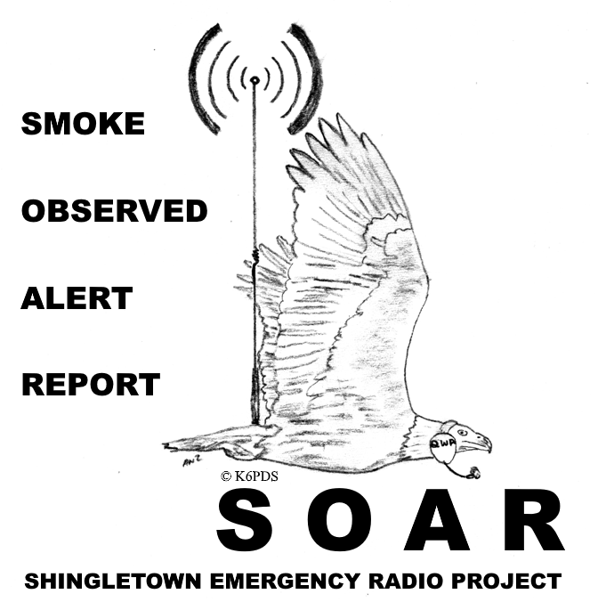

© COMMUNICATIONS PLAN DESIGNED BY and COMMUNITY SERVICE OF A. NATHAN ZELIFF, ESQ.

Thank you 5
In Memory of my Sister, Kathy. 6
OVERVIEW 7
NOW, YOU HAVE YOUR RADIO – NOW WHAT CHANNELS DO YOU LISTEN TO, AND WHAT ARE THEY USED FOR? 7
EACH PARTICIPATING AREA / NEIGHBORHOOD IS TO HAVE ITS SPECIFIC FREQUENCY ALLOCATIONS FOR “ALERT / EMERGENCY” COMMUNICATIONS AND ANOTHER FOR “OPERATIONS”. 7
EACH NEIGHBORHOOD [STATION – that’s YOU) CAN ACTIVATE THEIR NEIGHBORHOOD NETS & MAKE A CALL OUT ON THEIR OWN! 8
YOUR RADIO MUST BE ON 24/7 TO HEAR CALLS FROM NEIGHBORS! 8
MONITORING CHOICES: 8
CH 1 AND CH 3 – DIFFERENT USES: 8
NO CHIT CHAT – IF THAT IS YOUR INTENTION – GO AWAY! 10
FREQUENCY ALLOCATIONS – YOU MUST TEST. FREQ. ALLOCATIONS MAY CHANGE BASED ON TESTING RESULTS. 10
R-CTCS AND T-CTCS CODING 10
WARNINGS 11
NON – HAM BASIC STARTER FORMATS 12
OVERVIEW - PARTICIPANTS / CONTROL STATIONS / TACTICALS 12
1. AT THE AREA / NEIGHBORHOOD NET LEVEL: 13
“Village Foxtrot 1” 13
“Lead” 13
“ [your Area] Mapping 1” e.g., “Village Mapping 1” 13
“[your Area] Triangulation” e.g., “Village Triangulation” 13
“[your Area] Area Coordinator” e.g., “Village Area Coordinator” 13
2. AT THE HAM NET LEVEL: 13
FCC call sign of a Ham Station - e.g., “K6PDS:” 13
“Net Control” 13
“Fire Control” 13
“Mapping I” 13
“Mapping 2” 13
“Triangulation” 13
“Cal Fire Monitor” 13
“Tac 11” 14
A FEW FOUNDATIONAL BASICS – COMMON SENSE: 14
TONES / ALERTING PROCEDURES: 15
SER PLAN CHANGES (7/2021): 16
The SER Net Plan includes the following: 17
1. Situation Reports: 17
2. Fire Brevity Watch: 17
3. Smoke Check (format Tango 4): 17
4. Fire Net. 17
5. Triangulation on Smoke Column and estimating location for reporting. 17
6. Mobile Evacuation Net procedures: 17
7. RADIO RELAY TO 911 FROM MOBILE OR OTHER STATIONS NOT ABLE TO REACH 911 BY CELL OR OTHERWISE. 18
WHICH ONE WILL HIT YOUR NEIGHBORHOOD ? REFUSE TO BE A VICTIM. 18
CALIFORNIA STANDARD STATEWIDE EVACUATION TERMINOLOGY 18
EMBERS 19
PHONETIC-ALPHABET 19
SER Plan – NETS, SUB NETS / GROUND TEAM ACTIVATION – OVERVIEW 20
SER Plan – BASIC CONCEPT OVERVIEW FOR PUBLIC HAM NET AND NEIGHBORHOOD NETS 21
SHINGLETOWN DIVISIONS: 22
Area / Neighborhood Frequency Allocations – Purposes. 23
Area / Neighborhood Frequency Allocations – coordination and loss of Area Frequency. 23
SATELITES – (Deactivated) 23
SER Plan - Areas / Neighborhoods Channel 1 – Inter –Area Communications/MURS BACKBONE INTER-AREA COMMUNICATIONS 24
SER Plan - Ham Simplex 505 - Propagation (Home Base Stations) and Map Section reference FORMAT ROMEO 14H – 25
Base station to Base station / Base station to field locations propagation considerations 27
The SER Incident Resource page. 27
Q CODES AND and PLAIN ENGLISH: 28
Q codes are used during Situation Report Nets 28
Q codes are used for Fire Brevity Watch Reporting. 29
Plain English is used for emergency traffic. 29
What are these local "Q Codes" I hear? 29
HF NETS: 30
TACTICALS: 30
PRACTICE NETS, YOUR INVOLVEMENT AND PARTICIPATION: 31
WILDFIRE ALERT SAFETY PERIMETER (WASP). 33
WILDFIRE ALARM CORRIDOR (WAC) (SAY “SHINGLETOWN CORE”) 35
SITUATION REPORTS 36
SMOKE CHECK 37
Triangulation on Smoke Column 38
Fire Net Activations – Area / Neighborhoods – CRITERIA. (Below is for the Village. Other Areas should set standards for their Areas). (e-mail: 3/28/2021) 38
FIRE NET TACTICALS 39
EMERGENCY EVACUATION – MOBILE NET PROCEDURE (5/26/2021) 40
MOBILE REPORTING LOCATION REFERENCE (E-MAIL 5/13/2021. Rev. 7/52021) 42
MAPPING TOOLS; SMOKE LOOKOUT LOCATIONS; ROAD LOCATION AND MARKER REFERENCES; SAMPLE AREA MAP; SAMPLE AREA RESOURCE INVENTORY… 42
--------------------------------------------------------------

Thank you

THANK YOU TO THESE VERY SPECIAL EXTRA CLASS HAM OPERATORS WHO HAVE HELPED ME FROM THE BEGINNING AND OVER THE YEARS :
WB6CAN - PHIL
W6MAC - MAC
W6QWN – CHUCK

In Memory of my Sister, Kathy.

“Opportunity is missed by most people because it is
dressed in overalls and looks like work.”
Thomas A. Edison

OVERVIEW

This project is all volunteer. Its success or failure will depend on community action and active participation. If no one steps up, then the Plan will fail.

All of us are busy and work. Thus, people may not be available at the time of an emergency (they might be out of town, they might be dead, etc…). So don’t “rely” on neighbor “joe” to do for you what you should be doing for yourself. It is each persons responsibility to practice the SER Plan, and be able to help out. You can pick your level of involvement; however, a basic knowledge and understanding is essential. Actual practice is critical.

The program provides each person with an emergency communications PLAN capability when all else has failed (e.g., no electric, no cell phone, no land line, no internet, no reverse 911, … and there is a forest fire…) . You can listen to the Ham Fire Net for real time information; participate in your local Area Net for neighborhood net for your Area / Neighborhood emergencies (e.g., trees blocking the exit from your neighborhood and you need neighbors to bring chain saws and remove the tree(s), helping the elderly and disabled, etc…); Monitor Cal Fire; Monitor the Sheriff, etc… . If you are truly concerned about emergency communications, then step up and get involved. The Plan already exists. Don’t make “junk” up and destroy a Plan formulated based on hundreds of Nets (practice and Actual activations). The Plan exists and actually works. Just Plug in, follow the Plan, and do it.

The only station authorized to make any changes is K6PDS.

The only authoritative source for the SER PLAN is the web site www.ShastaDefense.com

NOW, YOU HAVE YOUR RADIO – NOW WHAT CHANNELS DO YOU LISTEN TO, AND WHAT ARE THEY USED FOR?

EACH PARTICIPATING AREA / NEIGHBORHOOD IS TO HAVE ITS SPECIFIC FREQUENCY ALLOCATIONS FOR “ALERT / EMERGENCY” COMMUNICATIONS AND ANOTHER FOR “OPERATIONS”.

CH 1. Alert / Emergency Communications Frequency-

THIS IS YOUR “ALERT / EMERGENCY FREQUENCY”.

CH 3. Operations Frequency-

THIS IS YOUR “OPS FREQUENCY”.

EACH NEIGHBORHOOD [STATION – that’s YOU) CAN ACTIVATE THEIR NEIGHBORHOOD NETS & MAKE A CALL OUT ON THEIR OWN!

YOUR RADIO MUST BE ON 24/7 TO HEAR CALLS FROM NEIGHBORS!

MONITORING CHOICES:

YOUR MINIMAL LEVAL OF MONITORING IS CH 1. BUT YOU WILL
MISS EMERGENCY NOTIFICATIONS FROM THE HAM NET.

SCAN DEFAULT IS: CH 1, CH 3, (AREA / NEIGHBORHOOD CHANNELS).
PLUS CH 10, CH 13. (HAM NET CHANNELS).

THIS LEVEL OF MONITORING IS RECOMMENDED AS IT ALERTS YOU TO BOTH YOUR NEIGHBORHOOD AND HAM ACTIVITY.
BUT, YOU WILL HEAR MORE RADIO TRAFFIC.

FOLLOW THE PLAN.

CH 1 AND CH 3 – DIFFERENT USES:

CH 1 IS YOUR AREA / NEIGHOBRHOOD ALERT FREQUENCY. ITS USE IS RESTRICTED TO THE FOLLOWING ONLY: [this FREQUENCY is to have NO TRAFFIC during periods of NO EMERGENCY/PRIORITY]

1. EMERGENCY / PRIORITY – FIRE / SMOKE COLUMN IN AREA
– MIKE MIKE 4 EARTHQUAKE OR ABOVE
– VOLCANIC ACTIVITY
– COMMUNICATIONS BLACKOUT
– FLYING EMBERS IN AREA
– SUSPECT SMOKE ODOR IN AREA
– POWER LINES DOWN
– GAS LEAK IN HOME

2. EMERGENCY – IMMEDIATE EVACUATION ORDER FROM SHERIFF.

3. EMERGENCY MEDICAL SITUATION.

4. PRIORITY – EVACUATION WARNING FROM SHERIFF.

5. SMOKE CHECK REPORTS (USE FORMAT TANGO 4) (Triangulation method to locate source of unknown fire / smoke with supplemental call to 911).

6. FIRE WATCH BREVITY CODES (SEE Format Mike 7).

7. EMERGENCY / PRIORITY COMMUNCIATIONS DURING AN EMERGENCY SITUATION - EXAMPLES:

A. WELFARE CHECK ON PERSONS DURING EMERGENCY SITUATIONS (ABOVE). (SUB NET MAY BE CONDUCTED ON CH 3),

B. TRAFFIC FLOW (ROADS OBSTRUCTED ETC…) DURING EMERGENCY
SITUATIONS (ABOVE). (SUB NET MAY BE CONDUCTED ON CH 3),

C. AREA RESOURCE UTILIZATION (E.G., IMMEDIATE NEED FOR CHAIN SAWS, TOW VEHICLES, GENERATORS, FOOD, WATER, MEDICAL, ETC…) DURING EMERGENCY SITUATIONS, ETC… (SUB NET MAY BE CONDUCTED ON CH 3).

D. SITUATION REPORTS DURING EMERGENCY / PRIORITY SITUATIONS,
USE FORMAT TANGO 9M

6. OTHER EMERGENCY / PRIORITY SITUATIONS.

7. PRACTICE NETS (E.G., SER PRACTICE NETS) – THIS IS AN EXCEPTION TO EMERGENCY USE.

CH 3 IS YOUR AREA / NEIGHBORHOOD OPS FREQUENCY. IT IS USED FOR AREA OPERATIONS & INCLUDES THE FOLLOWING: [this FREQUENCY may have TRAFFIC during periods of NO EMERGENCY/NO PRIORITY]

1. COORDINATING AREA RESOURCES DURING AN EMERGENCY.

2. STATIONS DIRECTING VEHICLE TRAFFIC AND COORDINATING ACTIVITIES DURING AN EMERGENCY.

3. COMMUNICATIONS THAT ARE NOT EMERGENCY OR PRIORITY – BUT ARE IMPORTANT AS TO THE AREA NEIGHBORHOOD (E.G., SUSPICIOUS VEHICLE (DO NOT ENGAGE – REPORT TO 911) DURING NON EMERGENCY / NON PRIORITY PERIODS).

4 USE FOR MAKING INITIAL CONTACT AND THEN QSY (CHANGE FREQUENCY) TO THE GENERAL TALK / CHAT FREQUENCY (I.E., CHANNEL #40).

.

NO CHIT CHAT – IF THAT IS YOUR INTENTION – GO AWAY!

THE ALERT FREQUENCY AND OPS FREQUENCY ARE NOT TO BE USED FOR CHIT CHAT. SUCH WILL DESTROY THE EMERGENCY MONITORING PURPOSE OF THE PLAN.

FOR CHIT CHAT GO TO NON PLAN FRS FREQUENCY >> 462.7250 NB ( NO CTCS IN or OUT).

FREQUENCY ALLOCATIONS – YOU MUST TEST. FREQ. ALLOCATIONS MAY CHANGE BASED ON TESTING RESULTS.

FMT YANKEE 5 SETS FORTH EACH AREA / NEIGHBORHOOD CH 1 THROUGH 4 FREQUENCY ALLOCATIONS.

FREQUENCY ALLOCATIONS ( FMT YANKEE 5) MAY NEED TO BE REVISED PENDING RESULTS OF AREA / NEIGHBORHOOD TESTING. IT IS CRITICAL THAT ALL AREAS / NEIGHBORHOODS CONDUCT TESTS WHILE ALL AREA ARE TRANSMITTING AT THE SAME TIME IN ORDER TO DETECT COMMUNICATION PROBLEMS!

R-CTCS AND T-CTCS CODING

BACKGROUND COMMENTS ABOUT DIFFERENCES BETWEEN CH #1 / CH #2 ; AND CH #3 / CH #4. THE PURPOSE OF R-CTCS AND T-CTCS CODING AS SET FORTH IN FORMAT YANKEE 5.

CH #1 is for Scan Monitoring. The purpose is to increase Area / Neighborhood monitoring (with a goal of 24/7 monitoring by Areas / Neigborhoods. Thus, the R-CTCS seeks to limit what you “hear on the radio” to only those alert communications related to your Area / Neighborhood. Thus, you should not hear miscellaneous radio traffic from those not participating in the emergency communications plan. However, a risk is that someone who has an emergency message may not be heard because their radio doesn’t contain the T-CTCS coding to open up the squelch on Area / Neighborhood radios programmed with the R-CTCS coding. Ch #3 duplicates this process for the Ops Frequency.

CH #2 (IS THE SAME FREQUENCY AS CH #1 - BUT “CTCS – IN” IS REMOVED):

CH 2 can be used for Emergency Communications AFTER an emergency alert has been sent on Ch #1. AT MINIMAL, THE “LEAD” Station(s) should switch from Ch #1 to Ch #2 TO BE ABLE TO HEAR ALL TRAFFIC AND INTERFERENCE.

By going to Ch #2, you should now be able to hear all stations transmitting on the frequency (if stations are within transmit / receive range), even if the transmitting station is not toned with the Area/Neighborhood Transmit CTCS code. The purpose is to allow all transmitting stations to be heard during an emergency situation (including those radio stations who have remained on Ch. #1, and also including those radio stations which have no T-CTCS programmed for the frequency, and/or have the wrong T-CTCS programmed. If however, a radio has the wrong R-CTCS programmed in it, then such station will not hear Area/Neighborhood communications on either Ch1 or Ch 2. Ch #4 duplicates this process for the Ops Frequency. If stations choose, they can Scan monitor Ch #2 (on a 24/7 basis), but this most likely will result in hearing miscellaneous communications (potentially at all hours of the day and/or night) which have no relationship to the emergency communications for your Area / Neighborhood.

WARNINGS

EACH AREA / NEIBGHBORHOOD IS RESPONSIBLE FOR ITS OWN TESTING TO MAKE SURE THAT ALL AREA / NEIGHBORHOOD STATIONS CAN BE HEARD AND COMMUNICATE.

IF YOU ARE NOT TESTING, THEN YOU ARE AT RISK OF COMMUNICATIONS FAILURE.

IF AREAS / NEIGHBORHOODS (AND EACH RESIDENT) NEGLECT TO PERFORM THE TESTING AND TAKE ANY NECESSARY REMEDIAL ACTIONS, THEN COMMUNICATIONS DURING AN EMERGENCY MAY FAIL. ULIMTATELY IS UP TO EACH INDIVIDUAL STATION OPERATOR TO MAKE HIS/HER RADIO STATION SUFFICIENT FOR EMERGNCY COMMUNICATIONS. DON’T WAIT UNTIL THERE IS AN EMERGENCY!

HAVE BACK UP RADIO(S)

HAVE BACK UP POWER SUPPLIES: BATTERIES / GENERATORS / SOLAR, ETC…

PLEASE CALL 474-3267 WITH YOUR TEST RESULTS. ATTEMPT WILL BE MADE TO REMEDY INTER-AREA COMMUNICATION INTERFERENCE BY RE-ALLOCATING FREQUENCIES. HOWEVER, THERE ARE ONLY A FEW FREQUENCIES AVAILABLE. THUS, YOU MUST FOLLOW PROPER RADIO PROCEDURES AND DISCIPLINE.

YOU MAY HEAR COMMUNICATEIONS NOT ASSOCIATED WITH THE SHINGLETOWN EMERGENCY RADIO NETS ON THESE FREQUENCIES. WE DON’T CONTROL THE FREQUENCIES AND OTHERS MAY BE USING THEM.

WARNING: YOU MUST RECEIVE A “ROGER” TO CONFIRM THAT YOUR RADIO TRANSMIT WAS RECEIVED AND NOT BLOCKED BY “HIDDEN” INTERFERENCE.

HOPEFULLY, ALL PERSONS USING THE FREQUENCIES WILL RECOGNIZE THE SEVERE FIRE DANGER WE ARE FACING AND WILL GIVE PRIORITY TO THE EMERGENCY COMMUNICATIONS PLAN THAT IS BEING USED.
EACH INDIVIDUAL IS SOLELY AND INDIVIDUALLY RESPONSIBLE FOR THEIR OWN RADIO SYSTEM, INCLUDING, BUT NOT LIMITED TO: RADIO(S), TYPE OF RADIO(S), BATTERIES, RADIO PROGRAMING, CONNECTIONS, ANTENNA, ALL COMPONENTS AND PARTS, MAINTENANCE AND MAINTENANCE CHECKS, AND ANY AND ALL RELATED MATTERS WHATSOEVER; AND IS SOLELY AND INDIVIDUALLY RESPONSIBLE FOR TESTING SUCH RADIO SYSTEM AND HIS/HER ABILITY OR NON ABILITY TO COMMUNICATE WITH OTHERS, AND RECOGNIZES THAT COMMUNITY INVOVLEMENT IS REQUIRED FOR THE PLAN TO WORK; AND IS SOLELY AND INDIVIDUALLY RESPONSIBLE FOR COMPLIANCE WITH ALL APPLICABLE LAWS AND REGULATIONS.

NON – HAM BASIC STARTER FORMATS

LINKS

FMT YANKEE 4 - NON HAMS PROGRAM THESE FREQUENCIES INTO YOUR RADIO

SITREP FMT TANGO 9M (NON HAMD AREA/NEIGHBORHOODS REPORT INTAKE)

FORMAT TANGO 4 SMOKE CHECK REPORT 4/09/2021
FORMAT TANGO 4 i - INSTRUCTIONS 4/9/2021
Compass Reading / Reporting - How to report Bearings on Fire / Smoke and Wind Direction.

OVERVIEW - PARTICIPANTS / CONTROL STATIONS / TACTICALS

Different Identifiers are given to Radio Operators based upon what tasks they are performing. For example, assume you are a participant in your Area / Neighobrhood and are listening to your Area / Neighborhood Net. You may here different Radio operators being referred to as “Lead”, Area Coordinator, Net Control, Mapping I, etc… . Such are called “tacticals”. Those names are assigned so that all stations know what that stations job is. So here is a summary of some of the Tacticals used.

1. AT THE AREA / NEIGHBORHOOD NET LEVEL:

“Village Foxtrot 1”

This an example of a specific participating radio station in the Area / Neighborhood designated “Village”. Each participating station in an Area / Neighobrhood should be assigned a Tactical. Suchg Tactical should be posted to your Area / Neighborhood MAP so your precise location is immediately identifiable by those running the Net and participating stations.

“Lead”

“ [your Area] Mapping 1” e.g., “Village Mapping 1”

“[your Area] Triangulation” e.g., “Village Triangulation”

“[your Area] Area Coordinator” e.g., “Village Area Coordinator”

2. AT THE HAM NET LEVEL:

FCC call sign of a Ham Station - e.g., “K6PDS:”

“Net Control”

“Fire Control”

“Mapping I”

“Mapping 2”

“Triangulation”

“Cal Fire Monitor”

“Tac 11”

A FEW FOUNDATIONAL BASICS – COMMON SENSE:

SEEKING TO COORDINATE EMERGENCY COMMUNICATIONS OVER a 100+ to 150 SQUARE MILE AREA , WITH MULIPLE DIFFERENT NEIGHBORHOODS , IS DIFFICULT ENOUGH.

Common sense dictates the fact that if different Areas use different forms, use different procedures, etc…, NOTHING will tie together. This is such a basic common sense concept, but there are Areas / Neighborhoods who have “cooked up” “stuff” that doesn’t tie in and which destroys the emergency communications system. If 12 Areas / Neighborhoods do things 12 different ways, then there is no plan.

For this to work, All Area/Neighborhoods must:

1. Follow the SER PLAN AND DOCUMENTS.

2. Use only SER PLAN DOCUMENTS.

3. www.ShastaDefense.com is the ONLY source for the SER Plan.

4. Don’t make “stuff” up.

5. Spend time practicing the SER Plan.

6. If your Area doesn’t have a Frequency Allocated, or has lost the prior Allocation because your Area doesn’t participate, or because your Area has “cooked up” its own procedures, forms, etc…; and/ or because your Area has interfered with emergency communications of other Areas, etc…; then your Area is to use Channel 40 (for non plan communications) so that you don’t interfere with other Areas which are actually following the Plan for All of Shingletown.

7. It isn’t fair for those who don’t follow the SER Plan, and who refuse to follow the SER Plan to interfere with those who are actually working to follow the SER Plan.

8. Setup your Area / Neighborhood Crews (e.g., to remove fallen tress blocking emergency evacuations and other Area / Neighborhood activities).

9. Setup your Area / Neighborhood Teams to conduct Welfare Checks on elderly / disabled.

10. Setup your Area Resource Inventory / Equipment list.

11 .Test your Area / Neighborhood Communications (ability to hear each other clearly).

12. Test your Inter-Area Communications (ability to communication with other Areas).

13. Participate in the weekly Practice Nets using the SER Plan and Documents.

14.You and your Area / Neighborhood need to participate in the SER Nets so that information sharing and reporting is provided to all of Shingletown. It is selfish for Areas / Neighborhoods to listen but not provide reports to other Areas / Neighborhoods. A fire 5 miles away, just may end up in your backyard. Accordingly, we all must be thinking in terms of Shingletown Total Area Wildfire Defense. The Camp Fire (2018) spread, at its peak, at the rate of 80 football fields a minute. The terrain was much like Shingletown. Some died in their cars as they were trying to escape.

15. Every Area / Neighborhood must have many people who can act as Area / Neighborhood Leads. You can’t have a system that relies only on a few people. All radio operators should be able to run the Area / Neighborhood Nets and they must follow the exact same SER Plan and Procedures.

16. Any Ham from any Area / Neighborhood may have to run the Ham SER Net. Again, it is imperative that the same SER Plan and Procedures be followed by anyone running the Net so everyone is doing the exact same thing. Respectfully, people need to stop making “Sh..” up and actually work the SER PLAN

17. Have your radios on 24/7.

TONES / ALERTING PROCEDURES:

SER USES “TONES” FOR SPECIFIC PURPOSES. EACH HAS A SPECIFIC AND DEFINED MEANING.

No Tone: you are attempting to reach a station, and it is NOT necessary that you receive a reply or response. If you are conducting propagation testing, do not tone.

Tone - Non Emergency: Five (5) very short tone bursts. This means that - I need you to listen and/or respond to me.

Tone - Emergency: Five (5) Long Tone T bursts for emergency / priority traffic. Means - All Stations – there is an emergency. For example, a new fire, a person needing emergency medical and they are not able to reach 911 by other means, etc...

Tone signaling during Net Operations is done to attract the attention of another Net Control station - Two (2) Short Tone Bursts. Fore example, an Area Coordinator may be on the Ham Frequency and conducting SER Net operations. Then an Area Lead desires to relay a report. The Area Coordinator is listening to both the Ham Frequency and Area Ch 1 (but is not focused on what is going on with respect to the Area CH 1 because the Area Lead is running the Area Net. The Area Coordinator will hear the Tones on CH 1 and take steps to direct attention to Ch 1 for the traffic.

We do NOT use the Red button on the Boefang.

How do you make the “Tones”:

1. Boefang press PTT then the band button. (1750 hz tone)

2. Icom 208H (microphone) FUNCTION KEY then tone-2 key.

3. Sending Modulated CW by holding microphone up to the speaker of the HF and sending CW tones.

Thus, and "e" which is a "dit” is the short sound (repeat 5 times)

Also, in place of an "e" send "i" which is “dit dit” (repeat 5 times)

Long tone T is sent as a LONG TONE T (a "dah") for about 1.5 seconds and repeat 5 times. The Long Tone T has been around for decades in Ham Radio.

4. If you have a different radio, consult your manual to determine how to make the proper Tone.

The above system works.

After testing, the SER Plan found that Tones will attract attention better than voice. Similar to the tones which Cal Fire uses.

The above SER Tones are to be used by all operators (Hams and Non Hams). Hams on Ham Frequencies; Non Hams on your CH 1.

On the SER frequencies these are what all stations are to use.

SER PLAN CHANGES (7/2021):

I have previously called on the telephone Ham operators when there was a fire near their home, and they were not responding on frequency. As of 7/15/2021 I will no longer be doing such. Each person can decide if they want to benefit from the SER Plan - that is their decision. Each Area can set up its own phone tree contacts.
The Foxtrot 1 special alerting option procedure & Foxtrot 1 frequency allocation is deactivated.

The SER Net Plan includes the following:

1. Situation Reports:

(Rapid assessment on such matters as: what areas don't have electricity, cell phone, land line, internet; lack ability to call 911 or receive reverse 911 calls; together with earthquake damage assessment information (e.g., buildings collapsed), etc...). See hyper Link Here SITUATION REPORTS SITUATION REPORTS

2. Fire Brevity Watch:

This includes a quick assessment (QWA Procedure) to determine if there is suspect, smoke, fire or embers in your neighborhood.

3. Smoke Check (format Tango 4):

Used when you smell suspect smoke, but don't know where the source is. This procedures has actually been used to locate the source of fire.

4. Fire Net.

For active fires and the real time providing of factual reports as to a fire's locations, distance to neighborhoods, wind direction, monitoring of cameras, monitoring wind speed and conditions, monitoring of Cal Fire dispatch and Tactical frequencies, flight radar monitoring, etc..., with all reports being made to a Fire Control station with Mapping and Triangulation. Stations (Ham and Non Ham) monitor such Fire Nets in Real Time.

5. Triangulation on Smoke Column and estimating location for reporting.

6. Mobile Evacuation Net procedures:

Used when all stations are fleeing the area with actual road reports being made from persons fleeing the Fire area (Hams and Non Hams) for the objective of giving immediate factual information as to road and travel conditions. Thus, if a road is blocked by wildfire, people need to know this before they turn down a road and get trapped. This is Real Time reporting, and a station at a specific location may be the only source of that vital life saving information at that moment. So, advise others over the radio so families may live.

To accomplish the above, the SER Plan has specific procedures that must be followed, which are described herein. Please don't debate SER Plan procedures during Nets (practice or actual activation). If groups and individuals decide to "cook stuff up", the system will not work.
We must all devote our energy to practice the SER PLAN AS WRITTEN. That way, in an emergency, we will be better prepared.

Improvements and modifications are continually in process based upon practice nets and actual activations (e.g., Forest Fires, Communications Blackouts, severe snow storms, etc….).

See discussion here: EMERGENCY EVACUATION – MOBILE NET PROCEDURE (5/26/2021)

7. RADIO RELAY TO 911 FROM MOBILE OR OTHER STATIONS NOT ABLE TO REACH 911 BY CELL OR OTHERWISE.

WHICH ONE WILL HIT YOUR NEIGHBORHOOD ? REFUSE TO BE A VICTIM.
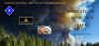 http://www.shastadefense.com/Which-One-Will-Hit001.jpg
IT IS UP TO ALL OF US !

CALIFORNIA STANDARD STATEWIDE EVACUATION TERMINOLOGY
Evacuation Order: Immediate threat to life. This is a lawful order to leave now. The area is lawfully closed to public access.
Evacuation Warning: Potential threat to life and/or property. Those who require additional time to evacuate, and those with pets and livestock should leave now.
Shelter in Place: Go indoors. Shut and lock doors and windows. Prepare to self-sustain until further notice and/or contacted by emergency personnel for additional direction.
Evacuation Order(s) Lifted: The formal announcement of lifting evacuations in an area currently under evacuation.
Hard Closure: Closed to all traffic except Fire and Law Enforcement.
Soft Closure: Closed to all traffic except Fire, Law Enforcement and critical Incident resources (i.e. Utility, Caltrans, City/County Roads etc. or those needed to repair or restore infrastructure).
Resident Only Closure: Soft closure with the additional allowance of residents and local government agencies assisting with response and recovery.
See document at this link: http://calalerts.org/evacuations.html

EMBERS
“An ember is a small, glowing piece of superheated wood, coal or other material that remains after (or sometimes precedes) a fire. Embers can glow as hot as the fire from which they arise, and are light enough to be carried by the wind for long distances without being extinguished. They’re the primary reason properties go up in flames whenever a wildfire is nearby.”
“An event known as an “ember attack” commonly occurs during bushfires. It causes burning parts of branches or leaves to become airborne and fly off as a large cluster of glowing embers. Not only can these embers be carried to the outside of your property, but they can make contact with the inside by floating through vents, windows or crawl spaces. As a result, they can ignite any and all flammable objects you own, including the house itself.”
See More about Embers at this link:
https://www.frontlinewildfire.com/why-embers-cause-the-most-damage-in-wildfires/

PHONETIC-ALPHABET
At this link: http://www.shastadefense.com/Phonetic-Alphabet.jpg

SER Plan – NETS, SUB NETS / GROUND TEAM ACTIVATION – OVERVIEW

LINK AT http://www.shastadefense.com/A-FmtLIMA00-radioConnOvervvRev20190523.pdf
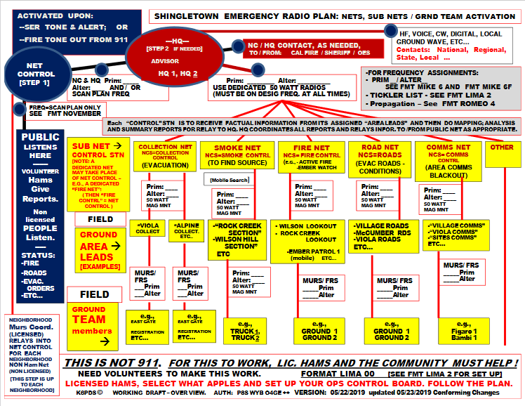

SER Plan – BASIC CONCEPT OVERVIEW FOR PUBLIC HAM NET AND NEIGHBORHOOD NETS

LINK http://www.shastadefense.com/A-FmtLIMA4-radioConnOvervvRev20190531.pdf
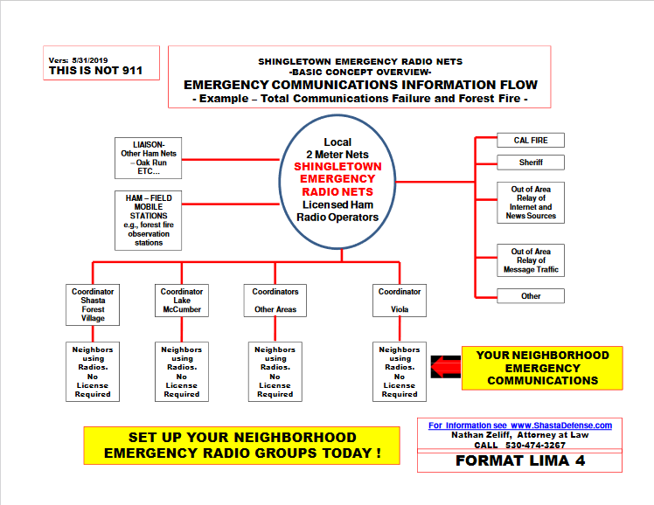

SHINGLETOWN DIVISIONS:

There are 5 Divisions, which are further divided into North and South. The Divisions are specifically defined by Township and Range. Individual Areas/Neighborhoods are defined by specific Sections within such Township and Ranges. The Basic concept is that each Area / Neighborhood is approximately 1 (one) mile square. The reality is that in bad weather, or emergencies, you will only be able to immediately assist people close to you. Traveling 3 miles through 3 plus feet of snow is not realistic. There are some Area size exceptions.

DIVISION 1  NORTH  T31N R2W | DIVISION 2  NORTH  T31N R1W | DIVISION 3  NORTH  T31N R1E | DIVISION 4  NORTH  T31N R2E | DIVISION 5  NORTH  T31N R3E
DIVISION 1  SOUTH  T 30N R2W | DIVISION 2  SOUTH  T30N R1W | DIVISION 3  SOUTH  T30N R1E | DIVISION 4  SOUTH  T30N R2E | DIVISION 5  SOUTH  T30N R3E

The Overview (not to scale) is (note that Satelites have been deactivated):

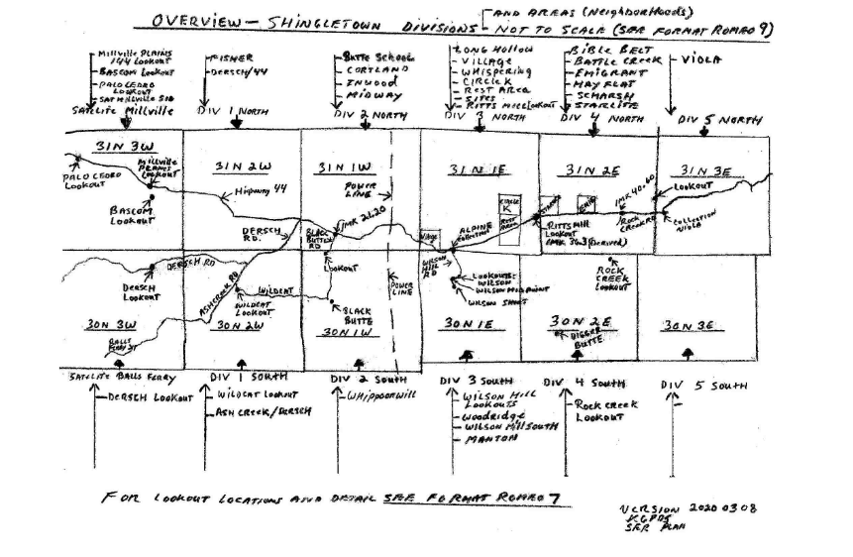
Each Area / Neighborhood is allocated a frequency pair, one for Emergency and the other for Operations. Due to limited frequencies, if an Area / Neighborhood does not follow the SER Plan and does not participate, then such frequency pair will be re-allocated to another area that is participating and helping Shingletown. The non participating Area / Neighborhood must then use Channel 40, which is a general FRS frequency for Chit Chat (Channel 40). Alternatively, such non participating Area / Neighborhood can figure out some other method which does not interfere with the Shingletown Emergency Radio Plan.

Area / Neighborhood Frequency Allocations – Purposes.

By each Area / Neighborhood having a dedicated frequency pair for EMERGENCY COMMUNICATIONS and another frequency for OPERATIONS, enhanced capabilities include:

1. potential for alerting a specific Area / Neighborhood of a situation without disturbing a large population. For example, a small fire is in a particular Area / Neighborhood and it is 2:00 A.M. in the morning. If you send out an alert on the Ham Frequency, then all Areas / Neighborhoods may be awakened.

2. seeking to enable Each Area / Neighborhood to conduct its own emergency communications and tasks while all other Areas / Neighborhoods are simultaneously conducting their emergency communications and task with the goal of having no or minimal radio interference between the Areas / Neighborhoods. Testing during practice nets is critical to achieving this goal.

3. insert.

Area / Neighborhood Frequency Allocations – coordination and loss of Area Frequency.

AREAS THAT HAVE NOT RECEIVED A FRQUENCY ALLOCATION, OR WHICH HAVE LOST THEIR PRIOR FREQUENCY ALLOCATION DUE TO FAILURE TO FOLLOW THE SER PLAN AND/OR NOT PARTICIPATING, AND/OR HAVE INTEREFERED WITH EMERGENCY COMMUNICATIONS, ARE TO USE CH 40 (CHIT CHAT, A NON PLAN FREQUENCY). THIS IS IS NECESSARY TO AVOID INTERFERENCE WITH THOSE AREAS WHICH ARE PARTICIPATING, FOLLOWING THE PLAN AND ASSISTING IN SHINGLETOWN FIRE AND EMERGENCY COMMUNICATIONS. THERE ARE LIMITED FRQEUENCIES AVAILABLE.

SATELITES – (Deactivated)

This was an effort to expand the SER Plan Emergency Communications system to areas outside the Formal Shingletown Divisions. However, there was no actual participation by any Satelite station. Accordingly, after much work and effort, the Satelite project has been deactivated and no plans exist to reactivate. Focus is upon the Five Shingletown Divisions.

SER Plan - Areas / Neighborhoods Channel 1 – Inter –Area Communications/MURS BACKBONE INTER-AREA COMMUNICATIONS

Link http://www.shastadefense.com/A-FmtROMEO-15-InterAreaRelay-2021.08.06.pdf

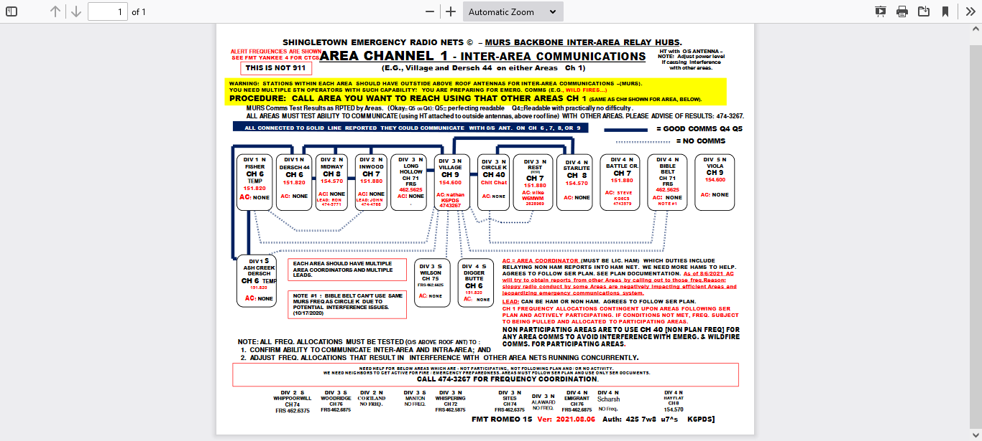

SER Plan - Ham Simplex 505 - Propagation (Home Base Stations) and Map Section reference FORMAT ROMEO 14H –
Link here: http://www.shastadefense.com/A-FmtROMEO-14H-InterAreaRelayHAMSIMPLEX-20210711.pdf
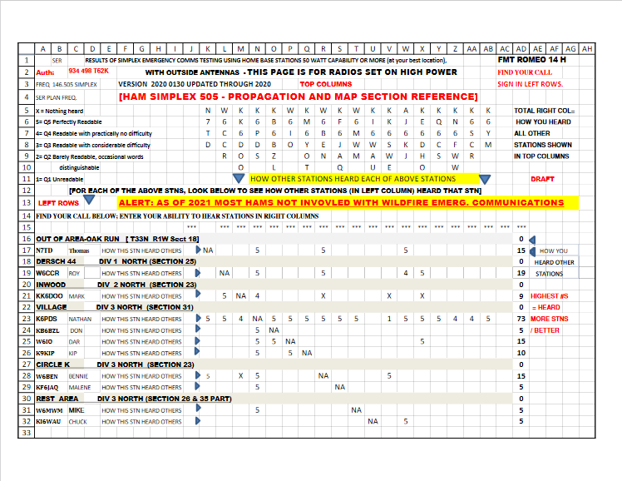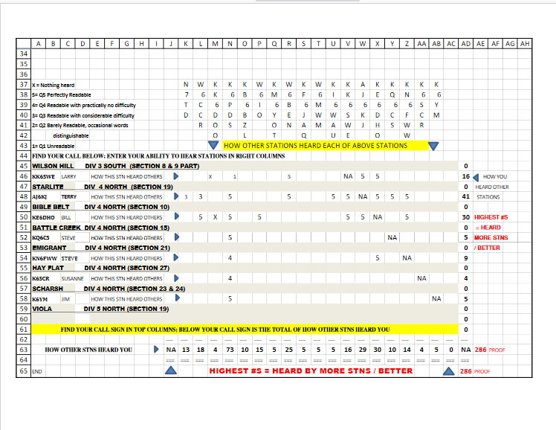

ALERT: As of July, 2021, most existing hams are not involved with Shingletown wildfire emergency communications. We need more Hams that have an interest in helping all of Shingletown as we are confronted by the HIGH LEVEL OF DANGER WHICH WE ALL FACE AT THIS VERY MOMENT. WE NEED NEW HAMS.

Testing of propagation is critical to determine stations that can act as Fire Controls and Relays on Simplex 505 in the event the 760 repeater is not available (e.g., burned off the mountain, mechanical failure, etc...). At this time there are only 4 Hams that are helping in our weekly practice drills.

If HAMS are not available during an emergency, then non hams MUST be prepared to step up to the plate and help out (following the SER Plan)!

There are Areas / Neighborhoods presently stranded without non-ham inter-area communications due to lack of Ham operators. View some of the fire burning at present. The Salt fire - 12,650 acres; Lava Fire - 26,162 acres; Tennant Fire - 10,580 acres; Beckwourth Complex - 86,076 acres. Imagine the impact of such fires if they hit Shingletown - most, if not all, of Shingletown would be gone!
July 2021 comment: If there are emergency communications in process on a Ham frequency, please use common sense, and do not interfere and obstruct by talking about FCC rules (e.g., requirement of Station ID, Non Hams using Frequency, etc...). The Actual FCC rules have been addressed by the SER Plan. A Ham operator recently interfered with an actual emergency communication and proceeded to talk over a 911 relay request, while the Ham injected his erroneous and false statement of the FCC "rule". The Ham apparently didn't even know what the actual rule was. The actual FCC rules were in fact being complied with. The blocking of a 911 relay request during an emergency situation is not responsible. We can all work together in these matters.

Base station to Base station / Base station to field locations propagation considerations

Link here: http://www.shastadefense.com/A-FmtROMEO4simplexMapping20160423.pdf

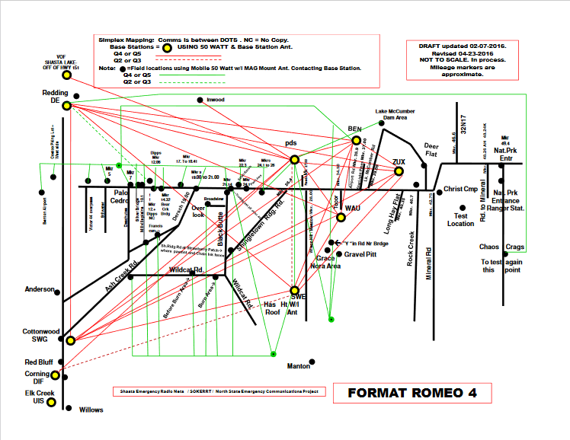

The SER Incident Resource page.

Link is here (e-mail 4/2/2021)
http://www.shastadefense.com/SER-Incident-Resources-Information.htm

ALL HAMS AND NON HAMS (neighborhoods) SHOULD USE THIS RESOURCE PAGE.
It can be used for locating fires, obtaining lat/long, camera views, aircraft radar. wind speed / directions, links to cal fire, links to sheriff, etc... .

IF YOU SEE A PROBLEM WITH THE PAGE, PLEASE ADVISE ME.

The Ham net uses these resources.

EACH NEIGHBORHOOD should use these same resources if you activate your neighborhood. Each AREA must be able to run their emergency nets. the Neihborhoods are essentially mini Ham Nets. Use the same procedures and don't make up junk.

Follow the SER Plan, use the correct terms and procedures. That way participating neighborhoods will be able to coordinate.

Check the page during the day / night to obtain information. Report if needed. You may find a new fire, not yet reported. One note of caution, the exact locations of fire are not necessarily as reported on the Internet Mapping. It appears that they will many times show lat / long for the incident command location which may be miles away from the actual fire.

In the event of a web site failure, or internet failure these resources will not be available. So on the ground reporting will be needed. Out of area assistance (e.g., stations 40 miles away could help because they have internet when Shingletown doesn't) - but we need Hams to assist. Many people still have their heads in the sand.

Each Neighborhood MUST take this seriously. Make sure your neighborhood uses the SER Procedures, have maps of your neighborhood with Tacticals for each station on the map, set up your Area road clearing crews / chainsaw crews, welfare check crews. etc.... . Sloppy warm and fuzzy talk won't work when the S... hits the fan. If a massive fire hit right now, is your neighborhood ready? Can you activate in 10 seconds with an actual system where you follow the steps. If you haven't practiced, then you are pretending. Without practice, you will find yourself staring at the wall dithering.

Be proactive and know what to do - it will reduce stress and may save your families life.

Q CODES AND and PLAIN ENGLISH:

Under the SER PLan:

Q codes are used during Situation Report Nets

[Format Tango 9A (Ham version) or Format Tango 9M (Area / Neighborhood version)] for rapid information gathering, posting, assessment and evaluation to be followed with recommendations by Net Control Stations [e.g., Ham Net or Area Lead (Area / Neighborhood)].

Q codes are used for Fire Brevity Watch Reporting.

Plain English is used for emergency traffic.

So, both Q Codes and Plain English are in fact used DEPENDING on what is being done.

What are these local "Q Codes" I hear?

During a Non emergency communication you may hear local Q Codes. Some ask, “Why don't you just say - "I don't see any smoke or fire...?" The REASON is because terms such as “smoke”, “Fire”, are trigger words causing potential concern / alarm to those monitoring. 24/7 monitoring is a primary goal of the SER Plan, and if trigger words are used, people will stop monitoring because they will get tired of going to the radio to confirm whether there is an actual fire or you were advising that there is “no fire”.

Some people say, Cal Fire and the Sheriff don’t use codes, they use plain English. Fist of all, such a statement is Not correct. Second, Cal Fire and the Sheriff don’t do what the SER Plan does and the SER Plan doesn’t do what Cal Fire or the Sheriff does.

We use our local Q Codes "QW_" series for the MONITORING portion of the smoke reporting program (seeking 24/7 monitoring). The Q Codes avoid long winded explanations, and provide defined brevity, and avoid the use of “trigger words” (e.g., like “fire”). (See Format Mike 7).

For example, the Q Code "QWA" involves specific defined steps a station takes before transmitting. Reading the meaning of “QWA” you see that the Q Code avoids the use of the trigger words "smoke" or "fire", while giving a DEFINED observation based upon specific actions you undertook to make that observation.

Consider this Q Code report:

"K6PDS, 760 QWT Millville Plains and 44 East Bound,
QWO Latour Butte, light, QWA, out".

It is clear and understandable even when you are not next to your radio, or when the radio reception is not real clear. Yes, you need to initially look up the meaning of the Q Code (format Mike 7). But only a few are routinely used.

Compare the above Q Code report to this non defined report:

"... hey Joe, I am looking around and I don't see any smoke or fire but looks like its a little smoky to the east of me".

If you look at the Q Code report, that message is very specific. A few words communicate a lot of information.

In contrast, the non defined report, doesn't advise whether the person is mobile, or at home. Doesn’t advise what frequency he is on (your radio was scanning and yout don’t know what frequency he was on because you weren’t looking at the radio when he transmitted). It doesn't tell you what steps the station took to make the report. It doesn't tell you whether the station has classified the "little smoky" as general atmospheric smoke / haze, or as smoke from a fire, etc... . You probably would have to go to the radio and ask.

One of the purposes of the monitoring plan is to have people "listening", and to avoid having back and forth "chatter" on the frequency plan. Such non defined "chatter" will result in operators turning off their radios.

If there is an actual fire event, we use plain English in our smoke net (Format Tango 4). The Reporting Nets are structured, brief and factual. Mapping and triangulation is part of the Smoke Net.

How about joining in?

And yes, Q Codes are proper on VHF. Under the Plan, you pick your level of involvement.

The SER Q codes are public, available on the Internet, and legal per contact with the FCC.

HF NETS:

HF NETS ARE CONDUCTED ONLY WHEN ACTIVATED.

TACTICALS:

Ham Net Activations – Tacticals:

During Net Activations, Tacticals are assigned by Net Control (or in the neighborhood, by the Lead, as needed).

Area / Neighborhood Tacticals:

In addition to using the Ham Net Type Tacticals (e.g., “village Mapping I”, etc…), each Area / Neighborhood should ASSIGN a Tactical ID for each station. Thus, in the Village, Nathan lives on Figaro, and his tactical is F1 (Foxtrot 1). The first letter of the street name is used for the Tactical. Each neighborhood Tactical should be posted to the Neighborhood Street Map (showing all addresses in the neighborhood). Thus, “F1” is written on the lot showing the location of Foxtrot 1. This allows rapid mapping during events. If the first letter of a Street in your area was already used (e.g., two streets have the same first letter), then use the Second Letter of the street name for Tactical IDS for those stations on that second street.

PRACTICE NETS, YOUR INVOLVEMENT AND PARTICIPATION:

Unless we have practiced, we will be a liability to ourselves and others.

The level of involvement is up to each of us.

To actually understand and appreciate the SER Plan, a person needs to have performed all SER Net Plan functions and know how they relate to each other. For example, some of these functions include: Net Control, Fire Control, Area Coordinator, Lead, mapping, Triangulation, Cal Fire Monitor, Tactical Monitor, Camera Viewing and determining the approximate areas viewed by the respective Cameras so that you can locate them on a physical map, estimate a fires location using landmarks, posting lat / long of a fire to a physical map, Reporting bearings and distances from SER Fire Lookout locations, triangulating smoke reports and estimate the location of a fire and be able to provide Township Range, and Section and/or Lat and Long to Cal Fire; use the Flight Radar tool to estimate the lat / long of a fire and post such location to the physical map, etc... .

As individuals, our radio report may take us less than 6 seconds to make (using the proper procedures), But, the system goes beyond merely each of us as individuals. The system is designed to coordinate all the reports. We Need more help to make this work.

At present, a concern is that all of the behind the scenes work is being performed by only a few stations. We need more Hams helping out. Just listening to a practice net or an actual fire, net is not helping.

Further, we can all see that when a station or neighborhood starts making things up, or debating the use of tacticals and procedures, this causes problems. Making errors or mistakes is fine. We all do that. And, by practice, we all improve. But for neighborhoods and individuals to "cook up" their own procedures is not.

Simple factual reports are made by individual stations in a specific manner, because, behind the scene a lot of work is done to rapidly assemble the information and then evaluate the information to make recommendations. This is not a social net. This is not CB radio. This is not rag chew. It is designed to be an emergency communication system.

ALL SER PLAN PUBLIC NETS ARE ON 760 (CH 10) AND/OR 505 (CH 13) ONLY! if he 760 repeater goes down, all public net activity is to be on 505 (Ch 13).

Subnets / operations may be on other Tactical Frequencies as directed by Net Control / Fire Control. However, such subnets / operations are not the Public Net.

The SER Plan objective is 24 hour 7 days a week monitoring of the Scan Plan. Please do not use the 760 or 505 frequencies after 8:00 P.M. or before 8:00 A.M., except for emergency traffic.

Please avoid saying on the Scan Plan 760 or 505 that you are "monitoring" or "listening". If you are actually doing the SER PLAN, you are actually monitoring the Plan Frequencies 24/7. To say you are "monitoring" or "listening" provides no value. If you are going to give a report, then give a report - e.g., "K6PDS 760, Village Div 3 North, QWA, OUT"

Please help out. We need more Hams. We also need non hams to learn the procedures so they can help out during an emergency when there are simply not enough Hams to help out.

With each station performing small tasks, the SER Plan system coordinates the information flow.

Please plug into the Shingletown Emergency Radio Communication Operations Plan and help out.
Nathan

WILDFIRE ALERT SAFETY PERIMETER (WASP).

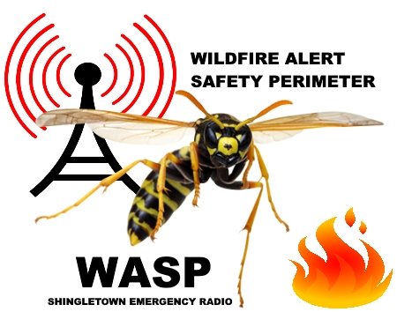
CALL 911 AND USE RADIO TO TX REPORT OF SMOKE AND FIRES LOCATED IN THE SHINGLETOWN
WILDFIRE ALERT SAFETY PERIMETER (WASP) MAP.
PURPOSE IS TO GIVE ADVANCE WARNING / ALERTING FOR MATTERS WITH DIVISIONAL IMPACT (e.g., fires that could spread quickly and impact Shingletown).
THIS SHOWS THE BOUNDARY AREAS FOR EVENTS THAT WE SHOULD WARN AND/OR ALERT AS TO TAKING PLACE IN THE SHINGLETOWN AREA.

"WASP MAP" SHINGLETOWN
WILDFIRE ALERT SAFETY PERIMETER
(Approx. Boundaries Lat/Long on image)
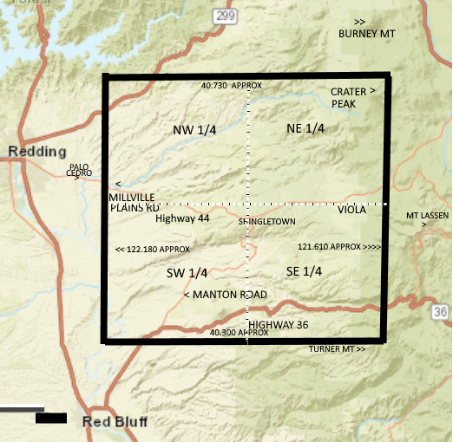
EXAMPLE: SAY "WASP MAP REPORT: APPROXIMATELY 17 LIGHTENING STRIKES, SOUTH 1/4 OF NE 1/4 BASED ON INTERNET LIGHTENING, QWL END REPORT, OUT (CALL SIGN)"

WILDFIRE ALARM CORRIDOR (WAC) (SAY “SHINGLETOWN CORE”)
PURPOSE IS TO DEFINE A VISIBLE GENERAL GEOGRAPHICAL PERMITTER FOR FIRE NET ACTIVATIONS WHICH CAN BE READILY DEFINED BY EASY TO IDENTIFY GEOGRAPHIC LANDMARKS FROM A DISTANCE (E.G., LOOKOUT LOCATIONS).
In the event a Wildfire is detected within this “SHINGLETOWN CORE”, FIRE NET ACTIVATIONS (EITHER ALL AREAS AND/OR SPECIFIC AREA NEIGHBORHOODS, DEPENDING ON FACTS AND CIRCUMSTANCES) IS STRONGLY RECOMMENDED.
During Wildfire season, the Shingletown Core can be considered a preliminary attempt at defining a GENERAL HIGH ALARM DANGER ZONE for Shingletown Areas. All Wildfires are potentially deadly and unpredictable. This effort is to seek to develop a preliminary FIRE NET ACTIVATION consideration. All of this is subject to judgment, common sense and conditions!

If you have recommendations, please contact SER.

To assist in defining the Shingletown Core, VISIBLE LANDMARKS are used which are observable from various lookouts (e.g., Millville Plains / 44; Bascom, etc…). Thus, quick visual reference can be made to determine whether fires are near or within this zone. Of course, a rapidly moving Wildfire outside the Shingletown Core may still necessitate a FIRE NET ACTIVATION. All of this is subject to judgment, common sense and conditions!

Shingletown Core Boundaries:

Northern Boundary (approx. latitude 40.605): An imaginary line is drawn from Latour Butte and continuing Westward and Parallel to the Southern Boundary. This forms the Northern Boundary (and is close to ).

Southern Boundary (approx latitude 40.430 ): An imaginary line is drawn from just south of Brokeoff Mountain and through a point just south of Black Butte. This forms the Southern Boundary (and is very close to the Digger Butte Area).

Eastern Boundary (approx longitude -121.646 East of Latour Butte which is about 2 miles East of Viola):

Western Boundary (approx longitude -122.060 ) Imaginary line from Bullskin Ridge (to the North) extending Southernly to Tuscan Buttes. This line runs through the Passing Lanes on Hwy 44 .

Modifications may be made based upon experience and input from users.

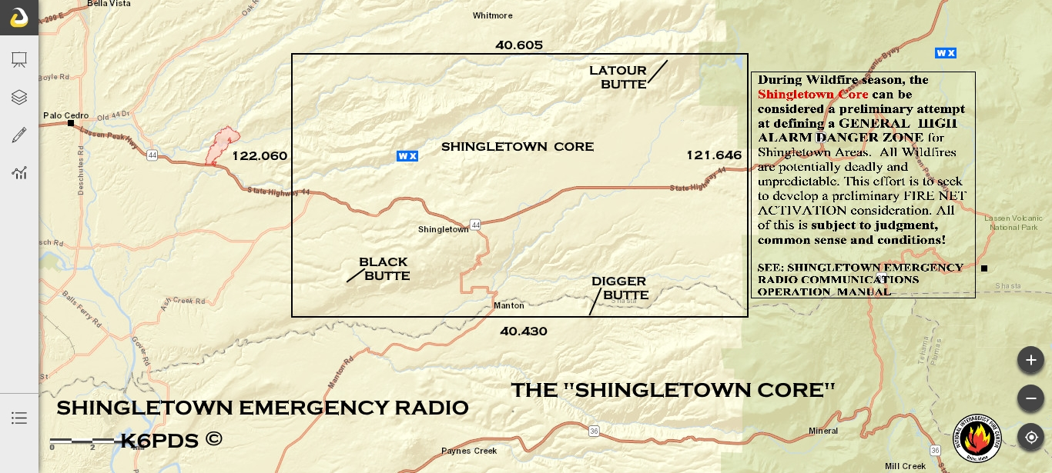

For Example, From Millville Plains and 44, you may see a smoke column in the Area of Oak Run. You called 911 and reported it, and then make the following report while mobile:
“ K6PDS, 760, QWT 44 MILLVILLE PLAINS EAST BOUND, SMOKE COLUMN IN OAK RUN AREA REPORTED TO 911. SHINGLETOWN COORIDOR QWA, out”.

SITUATION REPORTS

Area / Neighborhood reports are relayed into the Ham Net using Area Coordinators. Ham Mapping Stations are recording the summary reports as received and “mapping” them. You don’t hear this process during the Ham Net. A mapping board is used to post each Area / Neigborhood summary report by Division so that a rapid analysis can be done to determine problems and differences between Areas. This work is by “Mapping 1” and “Mapping 2”. FMT ROMEO 8 IS USED.

Link is here: http://www.shastadefense.com/A-FmtROMEO-8-MAPPING-2021.07.22.pdf

Instructions for use are: Net Control / Mapping 1 / Mapping 2, etc... FMT Romeo 8 (mapping) version 7/22/2021 (print horitonal / cut strip headers / tape on wall or board). Allow spacing below each HEADER so Tango 9A reports can be inserted below. Township Range and Section is used for the SER system. Shingletown is divided into 10 Divisions (each being a specific Township and Range) ( Div 1through 5 NORTH; and Div 1through 5 SOUTH). Satelites - deactivated and removed.) Updated Areas and Freq. Allocation.

Here is a sample view of such a Ham mapping board:
Image Link here: http://www.shastadefense.com/mapping20191031CCC.jpg

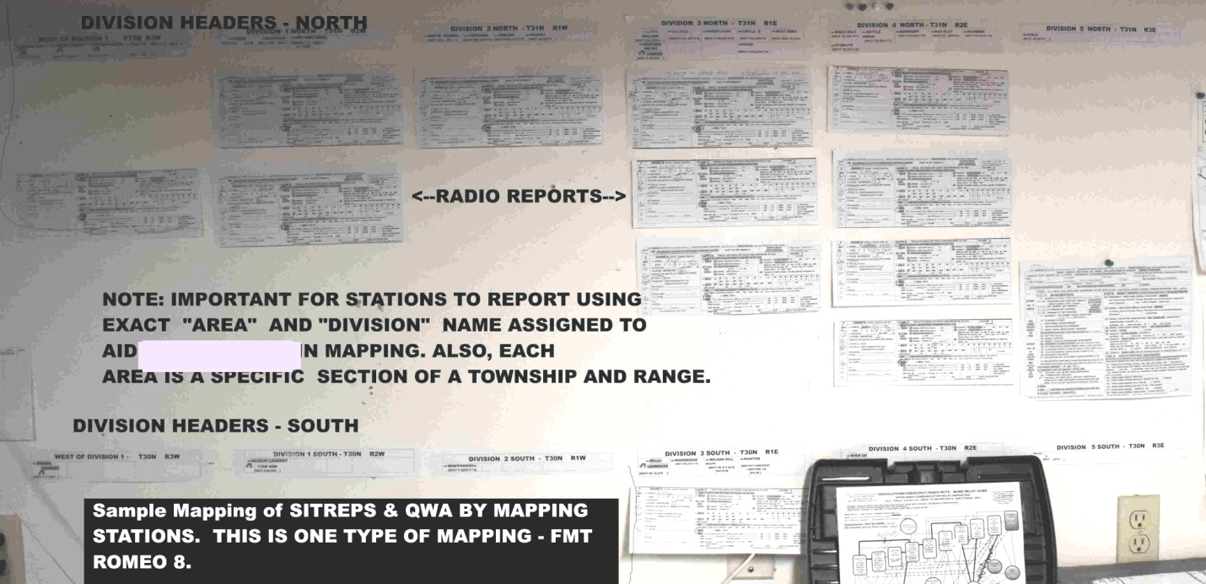

SMOKE CHECK

This procedure is for when you smell suspect smoke / fire but don't know the location. You have already called 911 and Cal Fire is searching. This procedure can help Cal Fire locate fires.

EACH AREA / NEIGHBORHOOD SHOULD HAVE ITS OWN TRIANGULATION STATION MAPPING ALL OF THAT AREAS REPORTS. A SUMMARY IS THEN PROVIDED INTO THE HAM NET (VIA AREA COORDINATOR - A HAM). [THE HAM NET ALSO NEEDS TRIANGULATION STATIONS TO MAP ALL SHINGLETOWN AREAS THAT REPORTED ].

REMEMBER - YOUR RADIOS SHOULD BE ON 24/7 - THAT IS WHAT THIS IS ABOUT.

Early detection is early response. Links are below.

 | REPORTS: SMOKE CHECK
HAMS - ALL OF SHINGLETOWN  AND NON HAMS AREA / NEIGHBORHOODS | FORMAT TANGO 4 SMOKE CHECK REPORT 4/09/2021  FORMAT TANGO 4 i - INSTRUCTIONS 4/9/2021  ILLUSTRATION OF WHY EVERY SMOKE CHECK REPORT IS IMPORTANT - EVEN THE "NO SMOKE ODOR"  FORMAT TANGO 4 T - SMOKE CHECK - TRIANGULATION STATION MAPPING TOOL (ONE WRITE)  For mapping - use Fmt Romeo 9a
 | Compass Reading / Reporting - How to report Bearings on Fire / Smoke and Wind Direction.

Triangulation on Smoke Column
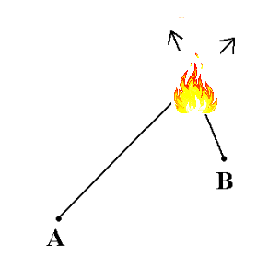

Fire Net Activations – Area / Neighborhoods – CRITERIA. (Below is for the Village. Other Areas should set standards for their Areas). (e-mail: 3/28/2021)

Each neighborhood should consider these matters.

FOR THE VILLAGE AREA, the issue is - when do we activate a VILLAGE FIRE NET? The time for PLANNING IS NOW, NOT DURING A FIRE!

Each Area should define its own Fire Activation Zone. For example, for the Village it is presently set at 3 miles from the Village (details below). Each Area must be able to activate on its own in the event of an emergency. That means each of us needs to step up to the plate.

For those relying on "Joe", you need to ask - what are you going to do when "Joe" left in the middle of the night for Las Vegas to play the slots, and didn't take you along? Now, what are YOU going to do? I mean about a fire, not about Joe when he gets back.

At this time, the preliminary recommendations / considerations for the Village Area are:

1. if there is a fire at or within 3 miles of the center of the Village Area, then activate the Fire Net on Ch 1 - (winds are not in excess of approximately 1 to 2 miles per hour.

2. If there is a fire at 4 miles out or closer to the Village Area, activate the Fire Net on Ch 1 - if the winds are 5 miles per hour or more.

3. Activation of the Village Fire Net for other further out distances depends on facts and circumstances, including, but not limited to: size of fire, rate of spread, terrain, wind direction , wind speed, other fires having limited Cal Fires ability to respond due to lack of resources, etc... .

4. If a fire is 10 (ten) miles away, for example, the VILLAGE FIRE NET would generally not be activated - EXCEPT if there are for example very strong winds, and / or other facts and circumstances (e.g., rate of spread, high wind speed, multiple fires in the Area, gound conditions, etc...).

5. All of above is subject to judgment, common sense and conditions!

6. Remember, Shasta Forest Drive is the only exit to the Village. Thus, early warning is critical for life and safety. Error on the side of Life and Safety.

Thank you Don Nichols and Doreen (Foxtrot 7) for your input.

As we practice, and have more fires this season, we will adjust the standards as appropriate.

If you have specific recommendations, please advise.

FIRE NET TACTICALS

For Check list of Tacticals see FMT KILO 1 APPEND F

Link is here:
http://www.shastadefense.com/A-Fmt-Kilo1-APPEND.%20%20F%20%20version2021.01.07-NetsAndFIREnetACTIVATION.pdf

FMT KILO 1 Append F Ham NET AND FIRE NET ACTIVATION RECORD - CHECK LIST OF TACTICALS ACTIVATED AND RECORD OF TRAFFIC. UPDATED 1/7/2021

EMERGENCY EVACUATION – MOBILE NET PROCEDURE (5/26/2021)

USE OF RADIOS DURING WILD FIRE EVACUATIONS:
DURING AN EVACUATION (E.G., SHERIFF MANDATORY EVACUATION ORDER, ETC…) REPORTS MAY BE TAKEN FROM HAMS AND NON HAMS ON 760 (CH 55) AND 505 (CH 58). SUCH ARE HAM FREQUENCIES.
THIS MOBILE PROCEDURE WAS PRACTICED RECENTLY BY HAMS ON 760 AS A DEMONSTRATION. THE PURPOSE IS TO PROVIDE ON THE SPOT REPORTING AS TO ROAD CONDITIONS (E.G., “VILLAGE FOXTROT 1 ON 760 -- WILSON HILL ROAD APPROX ½ MILE SOUTH OF HIGHWAY 44 BLOCKED BY FIRE BOTH SIDES AND TO THE SOUTH – DO NOT USE. I AM SAFE, RETURNING TO HIGHWAY 44, OUT”).
SHINGLETOWN EMERGENCY RADIO HAS A POLICY REGARDING USE BY NON HAMS OF HAM FREQUENCIES DURING EMERGENCY SITUATIONS WHEN THERE ARE INSUFFICIENT HAM OPERATORS AVAILABLE TO CONDUCT EMERGENCY COMMUNICATION OPERATIONS. IN ACCORDANCE WITH SER POLICY AND FCC RULES, NON HAMS MAY USE THE 760 HAM REPEATER AND 505 SIMPLEX HAM FREQUENCY FOR EMERGENCY COMMUNICATIONS ONLY. GO HERE FOR POLICY.
EXAMPLES INCLUDE: WHEN NO HAMS ARE AVAILABLE TO PROVIDE COMMUNICATIONS ASSISTANCE FOR COMMUNICATION TASKS RELATING TO IMMEDIATE SAFETY OF LIFE: WILD LAND FIRES - EVACUATIONS, NEIGHBORHOODS TRAPPED , ROADS BLOCKED BY FALLEN TREES, ETC...). ALSO, SUCH INCLUDES A NON HAM BEING AT A ROAD LOCATION WHICH IS BLOCKED BY FIRE AND WARNING OTHERS NOT TO USE SUCH ROAD FOR EVACUATION BECAUSE THEY WILL BE TRAPPED IN FIRE. POLICY IS IN COMPLIANCE WITH FCC RULES IN OPINION OF SER LEGAL COUNSEL.
Guidelines and Rules:
1. The Above SER Policy / Procedures for Radio Use During Evacuations (including, for example: Sheriff Mandatory Evacuation Order) are not for debate or discussion.
2. These procedures are to be followed.
3. If you don’t agree, or have a different viewpoint, keep it to yourself.
4. For Areas / Neighborhoods (Hams and Non Hams) that are too lazy to practice and don’t desire to practice proper radio procedures (E.G., long winded, non disciplined talk preventing Nets from operating and passing emergency traffic, etc…) – you can listen, but do not interfere.
5. During the above emergency life and death emergency conditions and operations, do NOT quote “FCC” regulations and tell people they are in “violation”. You are blocking and interfering with life and death communications, and people could die. The above policies are to be followed to save life.
6. The current Dixie Fire (as of 8/6/2021 – at 432,813 acres …, 35% contained… much of Greenville destroyed, …etc) should be sufficient to wake up any reasonable person to the threat of wildfire life and death conditions Shingletown could face at any moment – at the click of your fingers.
7. It is desired that ALL resident of Shingletown work together. This includes those who have different viewpoints and may disagree with the above SER Procedures.
However, the above SER procedures are to be followed.
Nathan Zeliff, Esq.
For practice sessions we need HAMS TO HELP OUT ON 760 (while mobile). If you can't go mobile, helping from home can also be done.

Link: EMERGENCY EVACUATION - MOBILE NET PROCEDURE

Individual Areas / Neighborhoods can practice this procedure on their Ch 1. In the event of evacuations, Non Hams would use these same procedures on the Ham Frequencies (as such being an emergency – people fleeing a wildfire to save lives). Sample drills are planned to be distributed for Area / Neighborhood practice.

MOBILE REPORTING LOCATION REFERENCE (E-MAIL 5/13/2021. Rev. 7/52021)

Below is used when you are mobile (for example). You called 911 and now you are alerting others. You need to be able to tell people where you are reporting from so that they can determine where you see the smoke column from.

You are on Highway 44 and see a smoke column at bearing 155 Degrees True. It is critical that you advise where you are, otherwise the bearing is worthless.

This is a format that shows mileage markers on Highway 44 and Lat / Long so that a station mapping can locate you on the map (format Romeo 9A). Mapping stations should be marking such map for Lat and Long. In the event of internet failure, mapping from the Internet will not be available. This reference seeks to allow reporting position locations to Maps.

This format is in process. SEE FORMAT ROMEO 6 (IN MAPPING TOOLS SECTION)

MAPPING TOOLS; SMOKE LOOKOUT LOCATIONS; ROAD LOCATION AND MARKER REFERENCES; SAMPLE AREA MAP; SAMPLE AREA RESOURCE INVENTORY…

HAM NET - PRIMARY MAPPING SUMMARY.
SUMMARIZES ALL AREAS / NEIGHORHOODS REPORTING.
REPORTING LOCATION REFERENCE MATERIALS.
FMT KILO - NCS Mapping Summary 2021.02.13 Sitreps, triangulation smoke/fire, Recommendations, Information, etc... Includes SUMMARY results of FMT ROMEO 8 MAPPING; AND Fmt Tango 4 smoke / fire triangulation... THIS IS A SUMMARY ONLY. NCS AND MAPPING TO USE TANGO 9A (PG 3) / TANGO 4 (PG 1) FOR ORIGINAL INTAKE, AND "MAP" USING FMT ROMEO 8 OR 9A AS APPLIES
All stations should copy mapping stations report to format KILO and then transmit (with plain english) into their individual neighborhoods immediately after closing of Ham Net. That way participating Areas / Neighborhoods know what is happening.
Net Control / Mapping 1 / Mapping 2, etc... FMT Romeo 8 (mapping) version 2/9/2020 (print horitonal / cut strip headers / tape on wall or board). Allow spacing below each HEADER so Tango 9A reports can be inserted below. Township Range and Section is used for the SER system. Shingletown is divided into 10 Divisions (each being a specific Township and Range) ( Div 1through 5 NORTH; and Div 1through 5 SOUTH). All other outside areas are SATELITES. Note: in process of updating. SATELITES HAVE BEEN REMOVED DUE TO LACK OF PARTICIPATION).
FMT ROMEO 9 - HERE OVERALL DIVISION MAP (ENLARGE IT ON YOUR SCREEN TO SEE) - well over 200 square miles. (THIS IS PRIOR VERSION - CONTACT NATHAN 474-3267 FOR CURRENT VERSION - PRINTED OUT MAP. THE ACTUAL MAP IS ROUGHLY 3' X 3'. (AREAS, AS OF THIS VERSION, CAN BE SEEN ON MAP). Enlarge on your screen to view this prior version. Newest Update must be used. call 474-3267
FMT ROMEO 9A - MAP FOR SMOKE CHECKS - MEASURES ABOUT 30 INCHES BY 40 INCHES. ELLIS IN REDDING WILL PRINT. A COLOR MAP FILE IS AVAILABLE TO PRINT OUT. CALL FOR FILE. 474-3267 - PRINTED OUT MAP
FMT ROMEO 7 - SMOKE LOOKOUT LOCATIONS (vers. 20171022 (form erroneously shows 2016, but is 2017 version)
FORMAT ROMEO 6 Highway 44 Road Markers and AND Other Locations for Reporting.

AREA / NEIGHBORHOOD NETS (E.G., NON HAMS):
AREA MAPPING (ILLUSTRATION) AND
AREA PREPARATION RECOMMENDATION
FMT ROMEO 21- VILLAGE MAP - VERSION 2020.06.22 - ALL OTHER AREAS/NEIGHBORHOODS SHOULD HAVE SUCH MAPS (LARGE IS ABOUT 36 INCHES WIDE (SMALLER VERSIONS CAN BE PRINTED).
FMT Romeo 22 Area Resource Inventory

END

